*Figure 2: Supply Bounce Across Capacitive Loads (In FF Corner)*

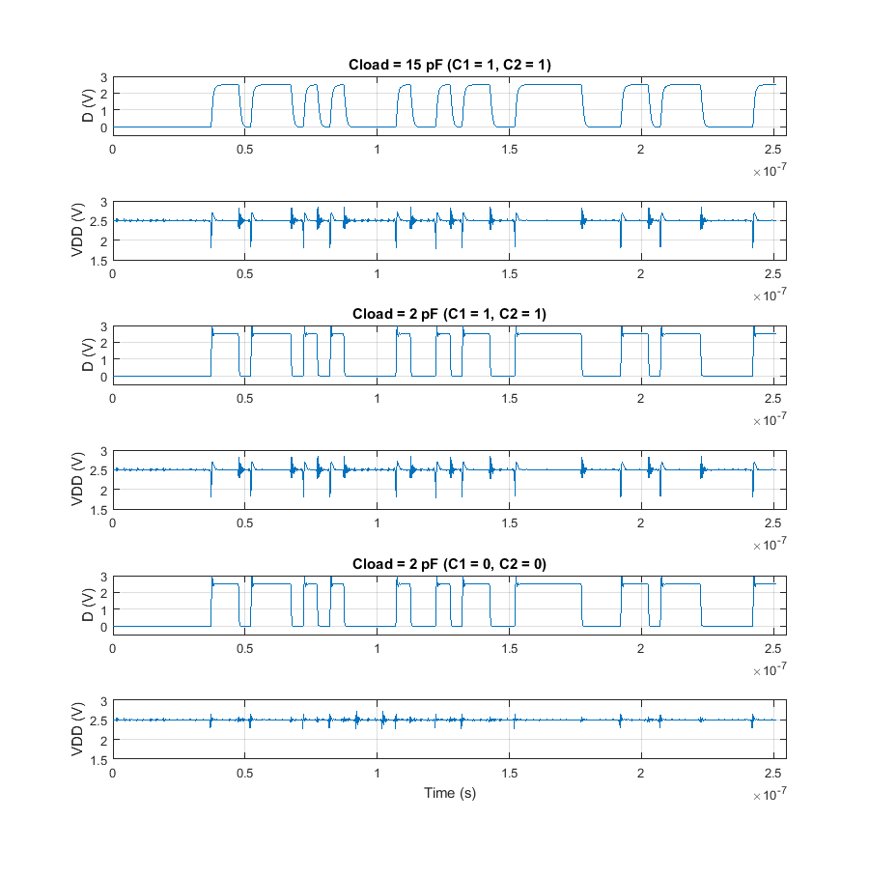

*Table 2: Maximum Peak-to-Peak Supply Bounce (In FF Corner)*

|  |  |
| --- | --- |
| Capacitive Load | Maximum Peak-to-Peak Supply Bounce |
| 15 pF (C1=1, C2=1) | 1.0516 V |
| 2 pF (C1=1, C2=1) | 1.2795 V |
| 2 pF (C1=0, C2=0) | 0.4523 V |

The voltage across an inductor is proportional to the time derivative of the current through the inductor. While very little current is supplied from VDD or dumped to GND when the output signal is constant, a large amount of current is moved when the output signal switches since every parasitic capacitor in the superbuffer connected to the output as well as the capacitive load at the output must be charged from GND to VDD or discharged from VDD to GND. When two inductors were introduced between the power supply and the supply rails of the system, this change in current induces a voltage drop across the inductors that changes the voltages of VDD and GND.

When the superbuffers drive the maximum designed load, they supply the minimum amount of current needed to achieve timing closure, but as the load is decreased below the maximum load, current is moved to or from the load faster than is necessary to achieve timing closure. As a result, for the maximum load, there is a minimum change in current which induces a small change in the power rails, and for loads that are below the maximum load, there is a larger change in current that induces a larger change in the power rails. The data presented for the system corroborates this theory.